Program Structure

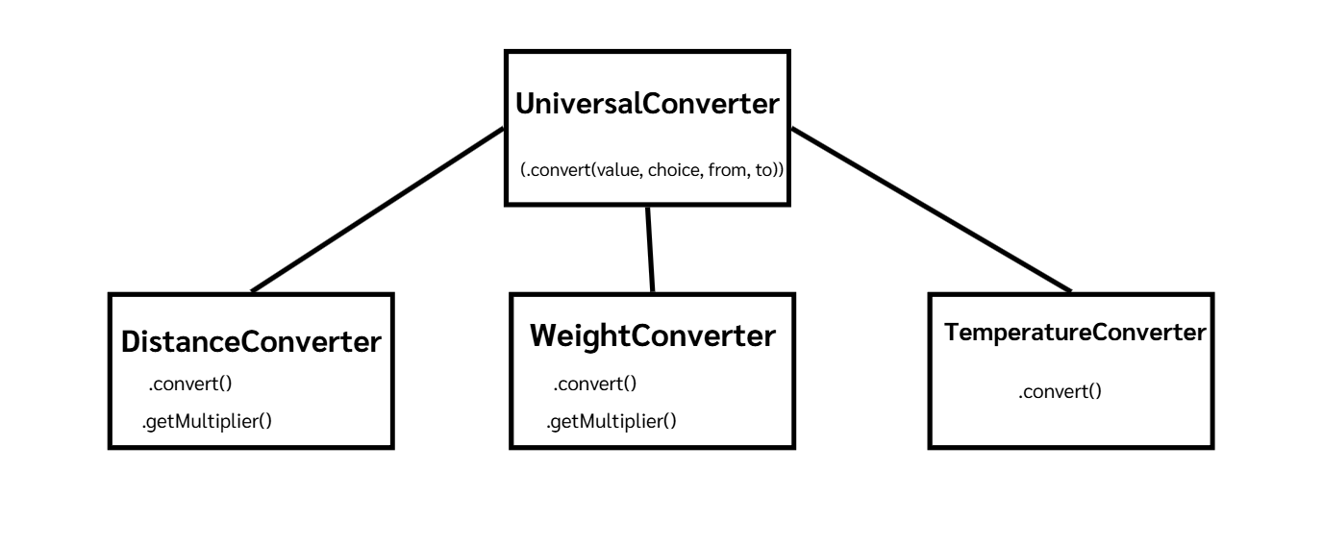

Top-down Integration

Unit under test | List of Stubs/Drivers | result | Stub’s return value | Expected results | Actual results | Pass/Fail/No run
UniversalConverter | DistanceConverterStub  WeightConverterStub  TemperatureConverterStub | convert(5.0, "Distance", "kilometer", "mile") | DistanceConverterStub.convert()  returns fixed 99.0 | 99.0 | 99.0 | Pass
UniversalConverter  + DistanceConverter (real) | WeightConverterStub  TemperatureConverterStub | convert(5.0, "Distance", "kilometer", "mile") | - | 3.105  (5 × 0.621) | 3.105 | Pass
UniversalConverter  + DistanceConverter (real)  + WeightConverter (real) | TemperatureConverterStub | convert(5.0, "Weight", "kilogram", "gram") | - | 5000.0  (5 × 1000) | 0.005 | Fail
UniversalConverter  (Full integration, no stub) | - | convert(100.0, "Temperature", "C", "F") | - | 212.0  ((100 × 9/5) + 32) | 132.0 | Fail

Bottom-up Integration

Unit under test | List of Stubs/Drivers | result | Stub’s return value | Expected results | Actual results | Pass/Fail/No run
DistanceConverter | ConverterDriver | convert(5.0, "kilometer", "mile") | - | 3.105  (5 × 0.621) | 3.105 | Pass
WeightConverter | ConverterDriver | convert(5.0, "kilogram", "gram") | - | 5000.0  (5 × 1000) | 0.005 | Fail
TemperatureConverter | ConverterDriver | convert(100.0, "C", "F") | - | 212.0  ((100 × 9/5) + 32) | 132.0 | Fail
UniversalConverter  + DistanceConverter | - | convert(5.0, "Distance", "kilometer", "mile") | - | 3.105 | 3.105 | Pass
UniversalConverter  + WeightConverter | - | convert(5.0, "Weight", "kilogram", "gram") | - | 5000.0 | 0.005 | Fail
UniversalConverter  (Full integration) | - | convert(100.0, "Temperature", "C", "F") | - | 212.0 | 132.0 | Fail

